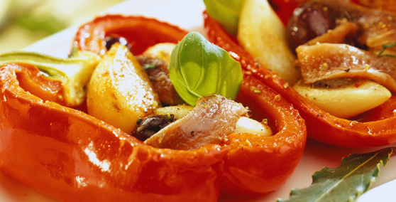
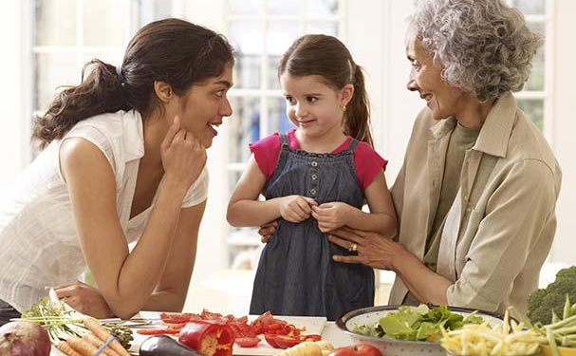

Cook with care for the ones you love.
Food Safety
In your home

Cook with CARE
C – clean everything
A – actual temperatures
R – real times
E – every day, everyone

All foods can cause foodborne illness. The people you care for the most – infants, older adults, and those with weakened immune systems – may be most harmed by foodborne illness.

Clean
Everything

Wash your hands: thoroughly and frequently

Wash hands and all exposed parts of arms upon entering the kitchen to cook or handle food, and as often as necessary while working in the kitchen. Wash hands after:
- Eating, drinking, smoking, or using the toilet
- Sneezing, touching your face or hair
- Touching or handling anything that may be contaminated with bacteria

How to wash your hands:
- Use plenty of hot running water, at least 100 F and enough soap to make a good lather.
- Rub hands together, washing hands, wrists, forearms, and under nails. Use a nail brush to clean thoroughly under nails and between fingers.
- Sing the A,B,C’s or “Happy Birthday” twice to yourself (or out loud for the entertainment of others) the entire time that you are washing. When you finish singing (at least 20 seconds), you have been washing your hands long enough.
- Rinse well under hot, running water. Use a clean, dry paper towel to turn off the faucet without touching the faucet handles, which may be soiled.
- Dry hands with a single-use paper towel.

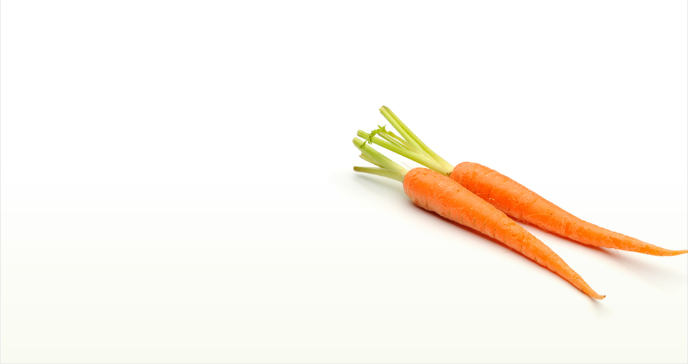
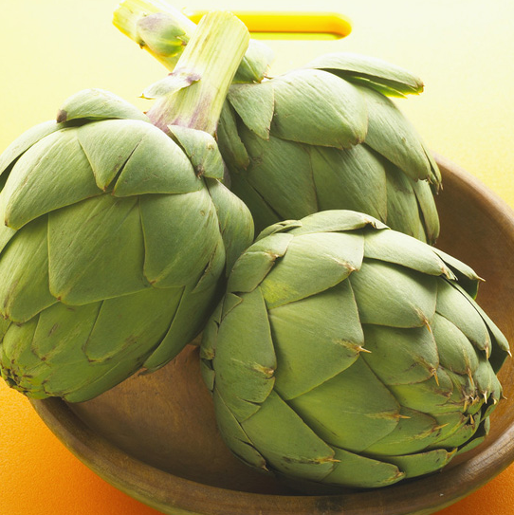
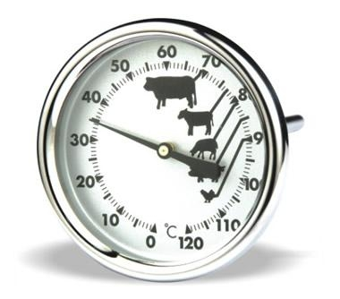
x
How to Use a Food Thermometer
Insert the stem of the thermometer into the thickest part of the food, away from bone, fat, or gristle (these can alter your reading). Wait 30 seconds, and then read the thermometer. Take temperatures for thin items like burgers within 1 minute; wait 5-10 minutes for larger items like roasts.
If the food is not yet cooked to a safe temperature, place the food back to continue cooking and clean the thermometer before you use it again.
After every use, including multiple uses during preparation of one meal, wash the thermometer in hot, soapy water.
Calibrate your thermometer: To check the calibration on your thermometer, place it in a cup of boiling water. If the thermometer does not register 212 degrees F, follow the instruction manual to adjust the calibration. On many stick thermometers, there is a calibration adjustment on the stem, near the dial.

C

clean everything

Actual Temperatures
Food color is NOT a reliable indicator that food has been cooked to a safe internal temperature.
Using a food thermometer is the only way to be certain that you have cooked an item properly.

Thaw Foods Properly
Foods should be thawed in the refrigerator, a water bath, or a microwave.
If you do thaw foods in the microwave, be certain to check the microwave setting to confirm that you are thawing the food. Food thawed in a microwave must be cooked that day.
Never thaw foods at room temperature or on the counter.

For more information, visit this USDA website: http://www.fsis.usda.gov/Fact_Sheets/Big_Thaw/

A

actual

temperatures

R
Real times

E

every day everyone

yone
Safe Internal Temperatures:

Whole Turkey – 185 F
Chicken – 165 F
Leftovers – 165 F
Eggs – 165 F
Ground Beef - 160 F
Steak
Medium Rare- 145 F
Medium – 160 F
Well - 170

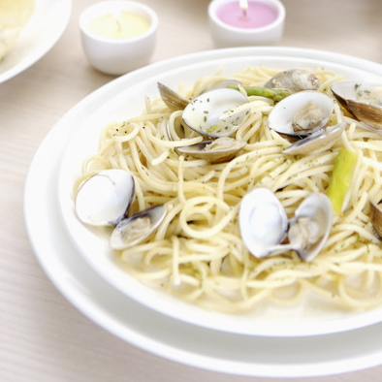
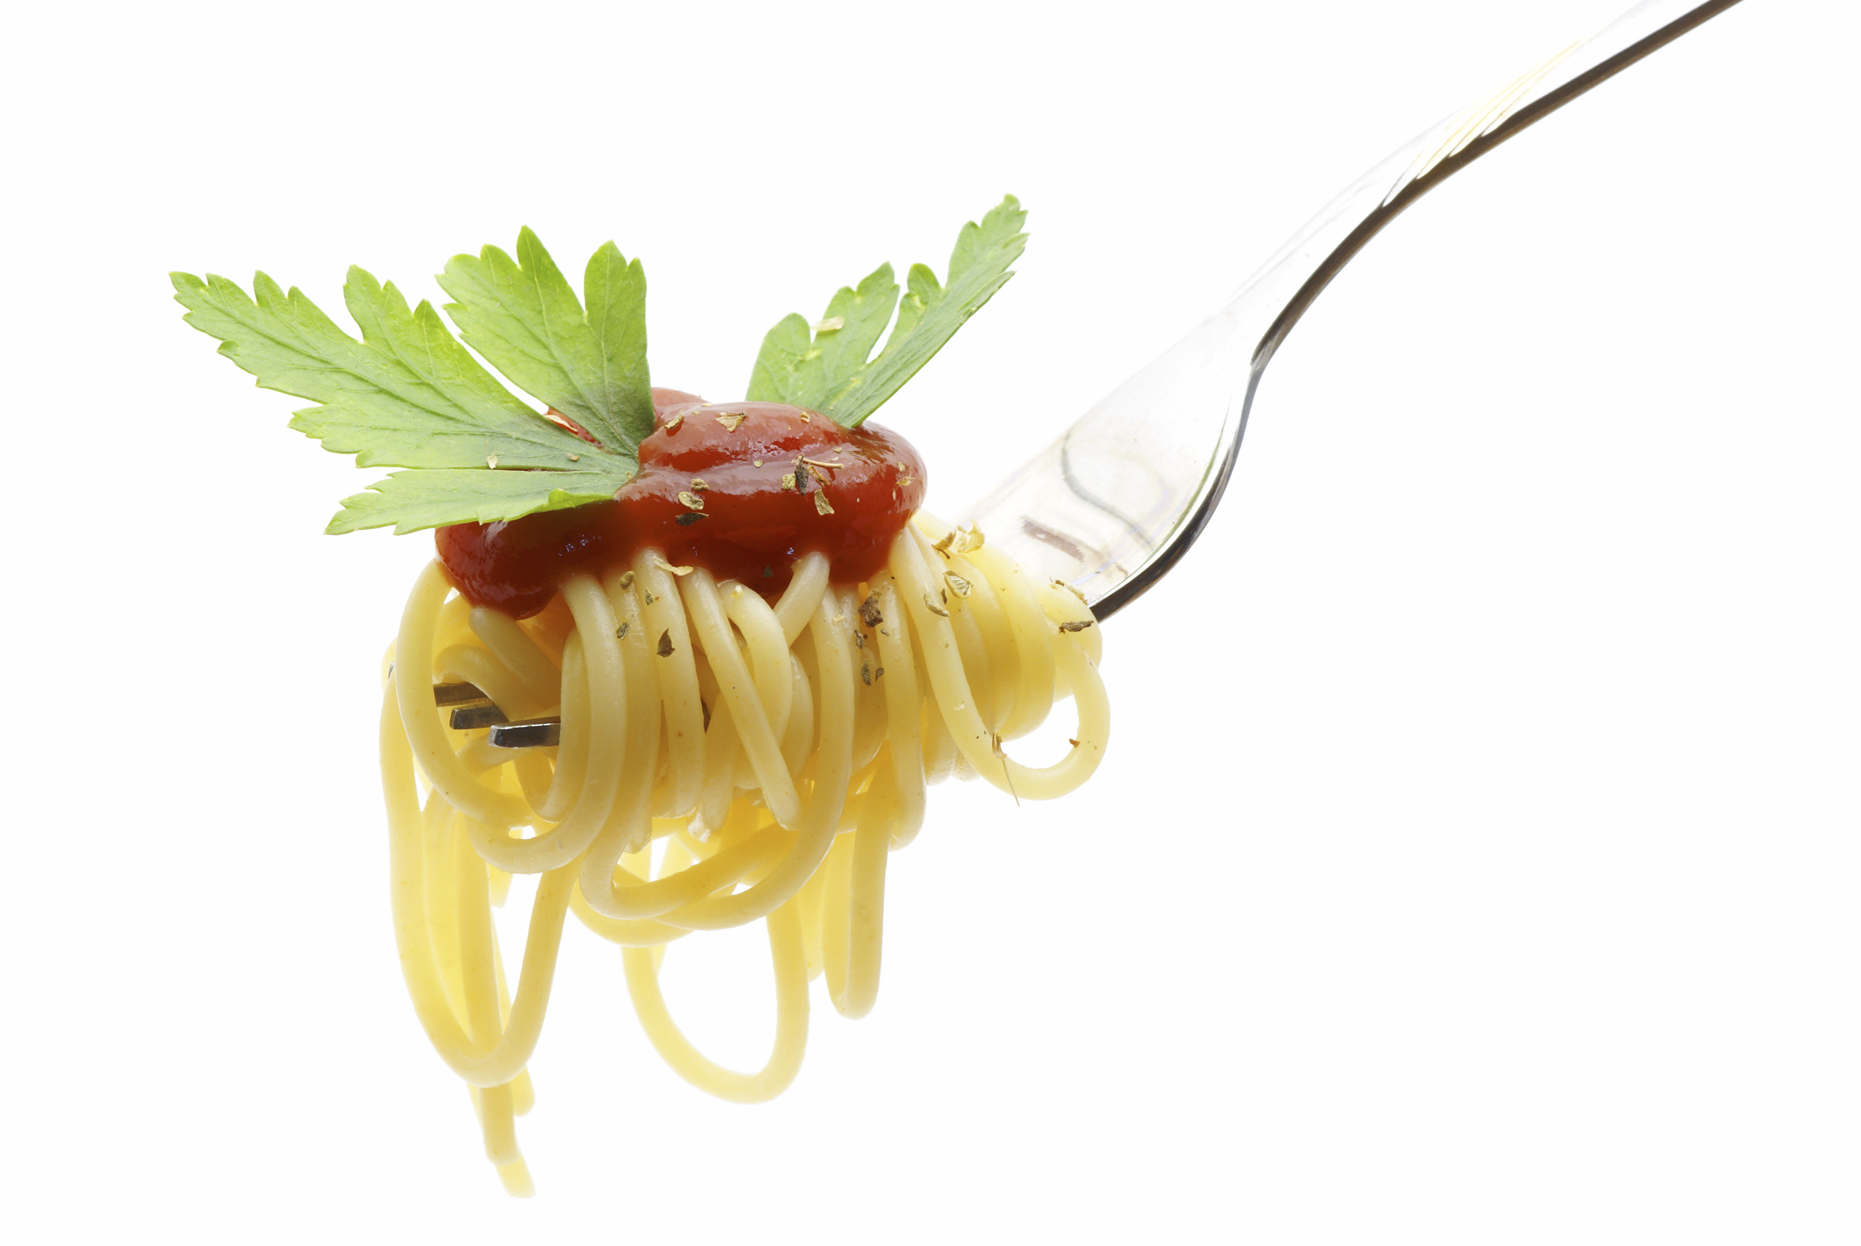
Store Food Properly
Dry Food Items like flour, cereals, breads, chips, oils, canned foods, bottled foods, and pre-packaged cookies.
- Store these items in a cool, dry place. Keep them off the floor, away from walls, and NOT under a sewer line.
- Keep all containers tightly closed, and discard when expiration dates are reached.
Cold Food Cold foods must be kept in a refrigerator or freezer.
- Label and date all items.
- Tightly wrap items
- Keep frozen foods at 0 F or lower.
Chemicals & Cleaning Products Store these items in cupboards separate from food.

Shopping Tips Food safety begins at the market. Invest time during checkout to make certain that like products are bagged together based on food type and temperature. Be certain to unpack the car and put groceries away in a timely fashion, especially during hot and humid weather.
- Meats, poultry and proteins go together in a bag
- Fruits and vegetables go together in a bag
- Cleaning products are separated from food in a different bag

C

clean everything

A

actual

temperatures

E

every day everyone

yone

R

real

times

Real Times:
41-135F < 4 hours
Perishable foods must be kept out of the Food Danger Zone. The Food Temperature Danger Zone is 41-135 F. In this range, bacterial growth is most likely to occur.
Do not let any food remain in the Food Temperature Danger Zone for a cumulative total of more than 4 hours.
Food that has spent more than 4 hours in the Food Temperature Danger Zone is unsafe and should be discarded.
Temperature Danger Zone:
41-135F

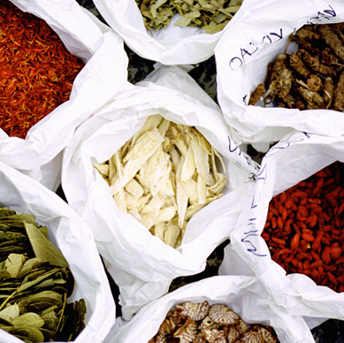
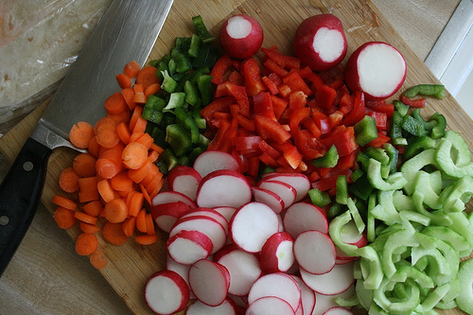
Everyone, every day
Cross contamination is the transfer of hazardous microorganisms from one food to another, from a surface to food, or from a food to a surface. Examples:
- Wiping down surfaces with a soiled cloth
- Cutting open a bag of vegetables using the same scissors (un-sanitized) that were previously used to open a package of raw chicken.
- Cutting an apple on a cutting board that was previously used for cutting fish.
Cutting Boards
Prevent cross-contamination by having at least two cutting boards.
Mark one for use for produce and the other for proteins.
Take care to clean cutting boards well after each use.
2+

C

clean everything

A

actual

temperatures

E

every day everyone

yone

R

real

times

Microwave Ovens Use care when cooking, thawing, and re-heating foods. Cover foods to prevent splatter on the inside of the oven. Clean the inside of the oven, including the roof and door, regularly. Note that food thawed in a microwave oven must be cooked that same day.

