## LIV MAS/LIVE MORE

## *An energetic card game for all ages*

## *that teaches how to make healthier food choices when it comes to Mexican Food*

## NTD 411

## Hypertension Project

## Samantha Gogets Keri Palasz Nora Tramontina

## LIV MAS/LIVE MORE

## *An energetic card game for all ages*

## *that teaches how to make healthier food choices when it comes to Mexican Food*

## *Ideal for 3-4 players per deck.*

## How to play:

1. Deal out all cards face down to all the players as evenly as possible. Do not look at your cards. Use one deck for less than four players and two decks if you have more than four. Choose to play Jokers Are Wild or to remove Jokers from deck prior to play.
2. Turn up one card in the center of the table, starting with the player to the left of the dealer, creating a “river” of cards.
3. Slap the pile of cards if an Inferior Food card is turned up, regardless of suit. The first person to notice the Inferior Food card slaps their hand down on the pile of cards, yelling “Liv Mas!” (You may not slap your own card.)
4. After slapping the Inferior Food card, the player should explain what foods might be superior choices to the inferior food on the card just slapped. For example, if a player slaps the Inferior Food card, “Hot Sauce” he or she would then explain that a Superior Food choice would be “Fresh Jalapeno Pepper.”
5. At this point, the other players quickly check their cards. The first player to slap a “Fresh Jalapeno Pepper” Superior Food card on top of the “Hot Sauce” card wins the pile.
6. Place the pile of won cards into the winner's existing face-down pile of cards. The player to the left of the winner turns up the next card in the center of the table, starting the next play.
7. Rotate to the next player, allowing them to place a card face up. Continue through all the players, slapping Inferior Food cards as the game progresses.
8. Continue play. If a player has run out of cards, but still has face up cards in play in the “river”, they may continue to slap Inferior Food cards, winning cards in order to stay in the game. If they are entirely out of cards, they are disqualified and the game continues.
9. Forfeit one card if you accidentally slap something other than an Inferior Food card. You must give one card from your face down pile to the person whose card you slapped.
10. The winner is person with the largest pile of won cards.

**Inferior Food Cards**

These foods are high in sodium and low in potassium.

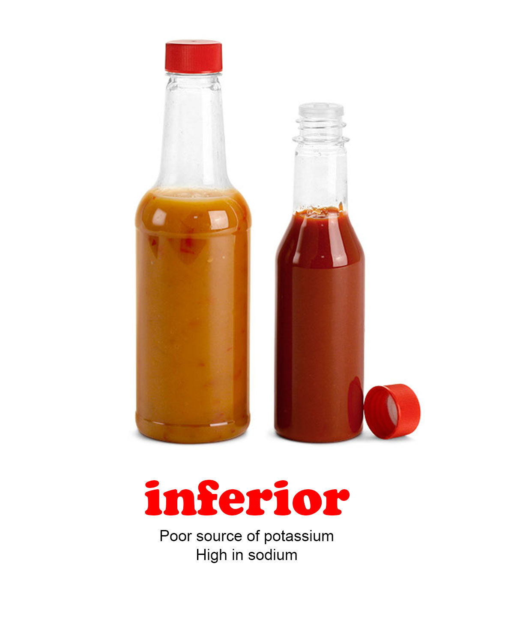 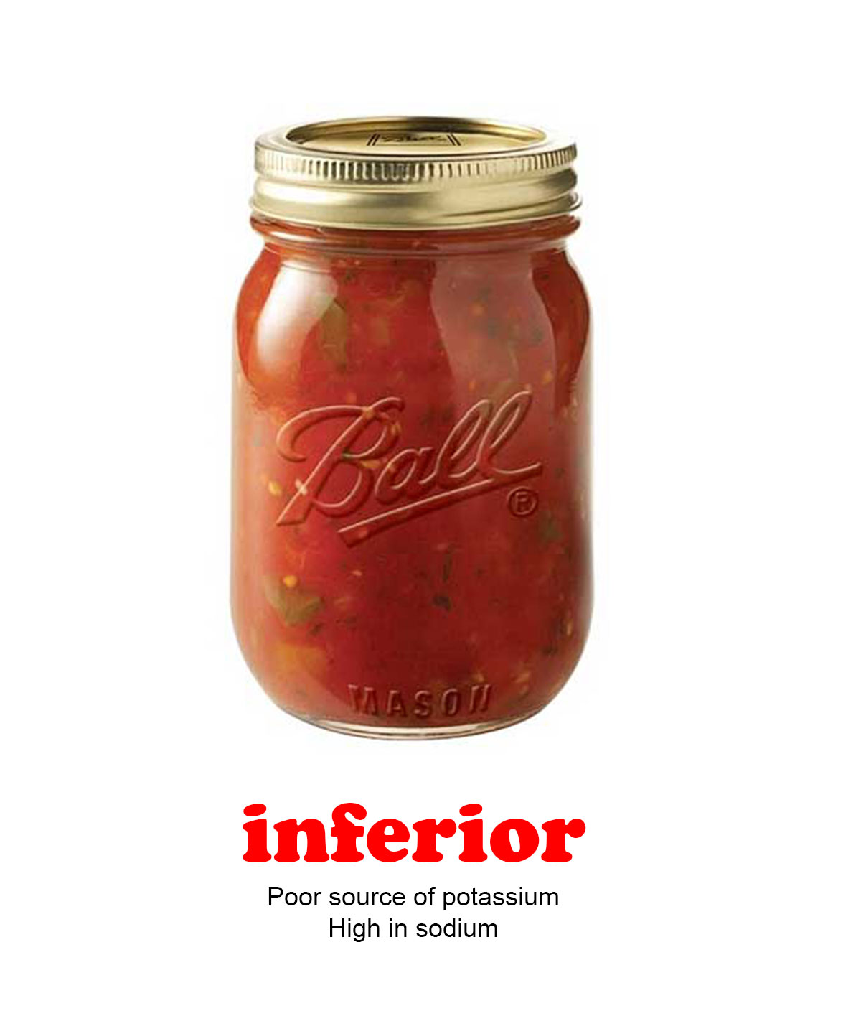 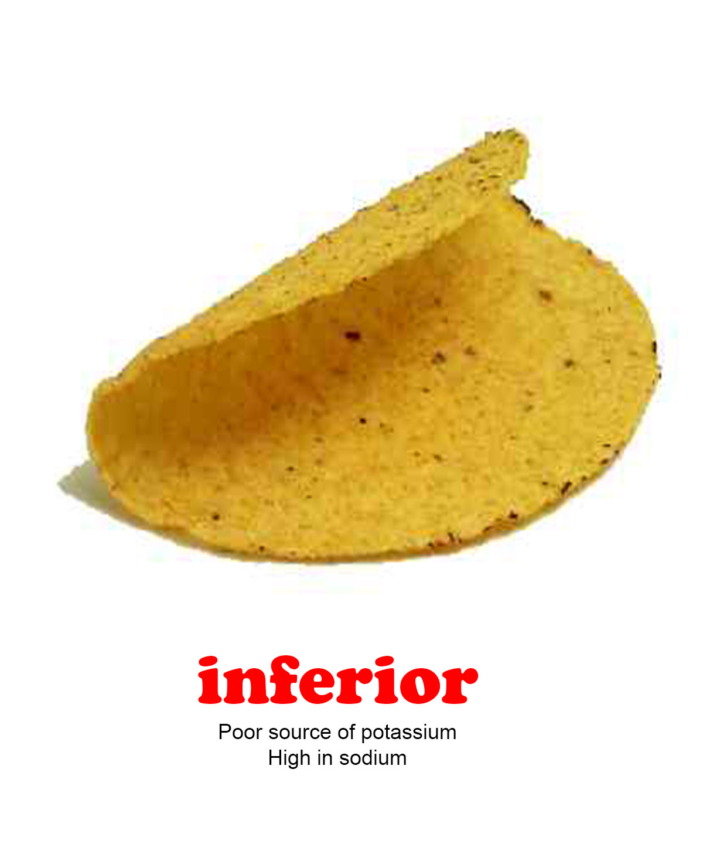 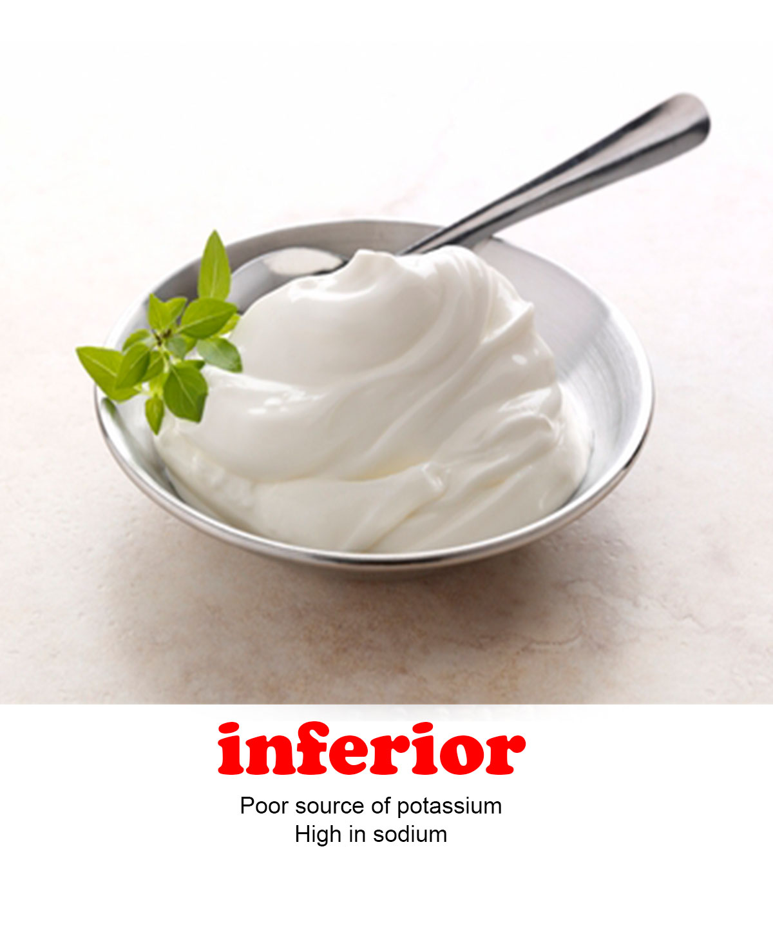

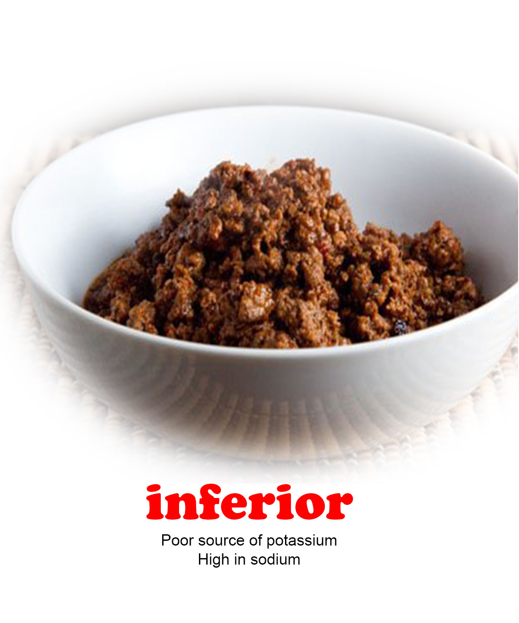 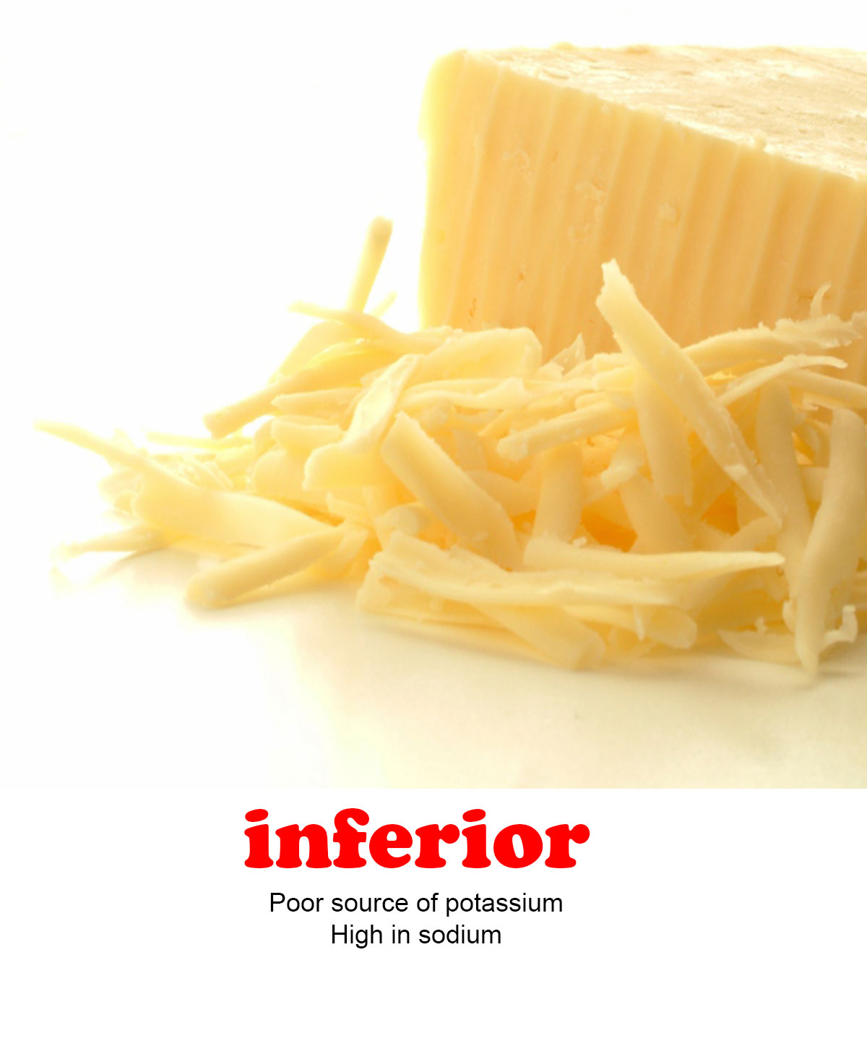

**Superior Food Cards**

These foods are low in sodium and high in potassium. Here are some suggestions for how to use them to defeat an inferior card, which also makes a recipe healthier with respect to sodium and potassium content.

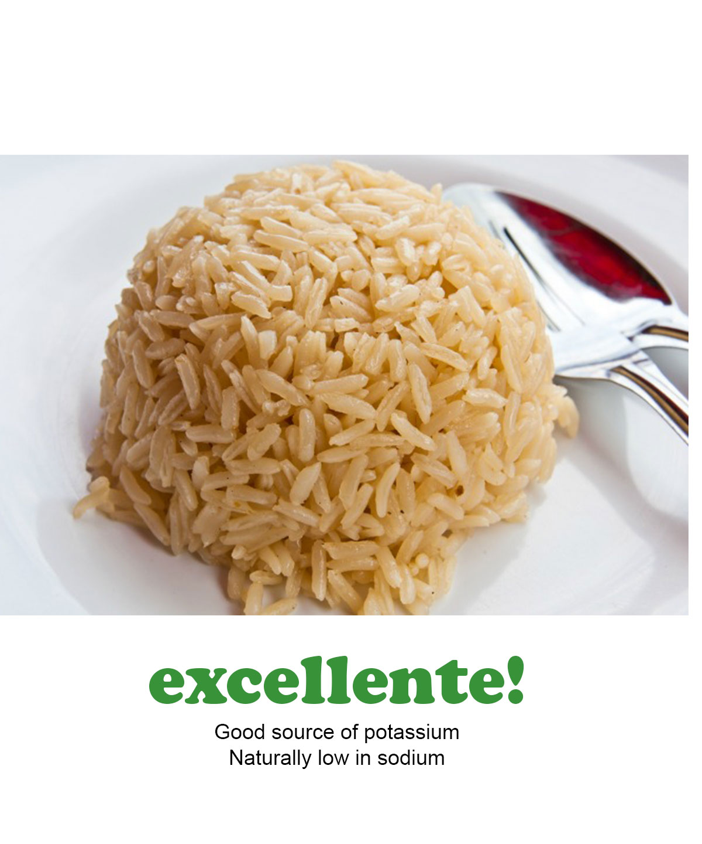 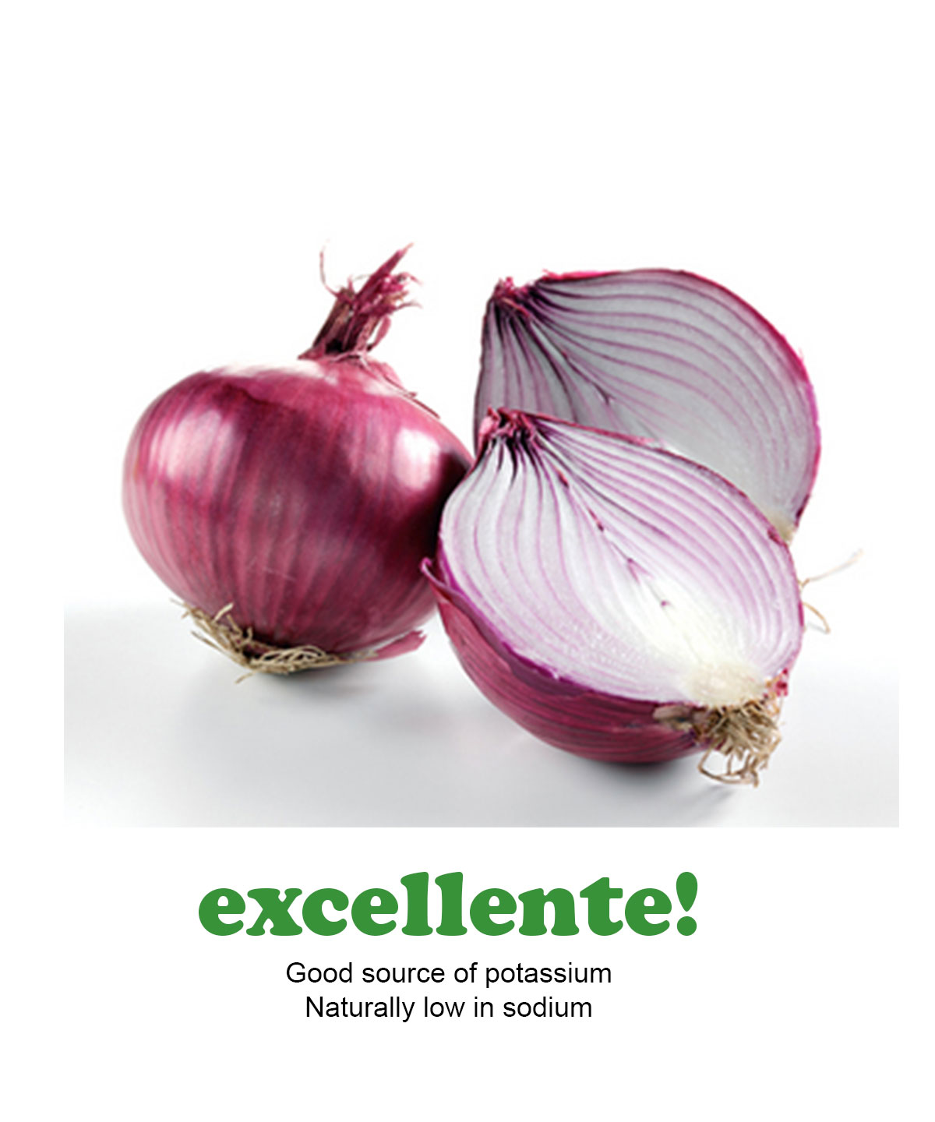 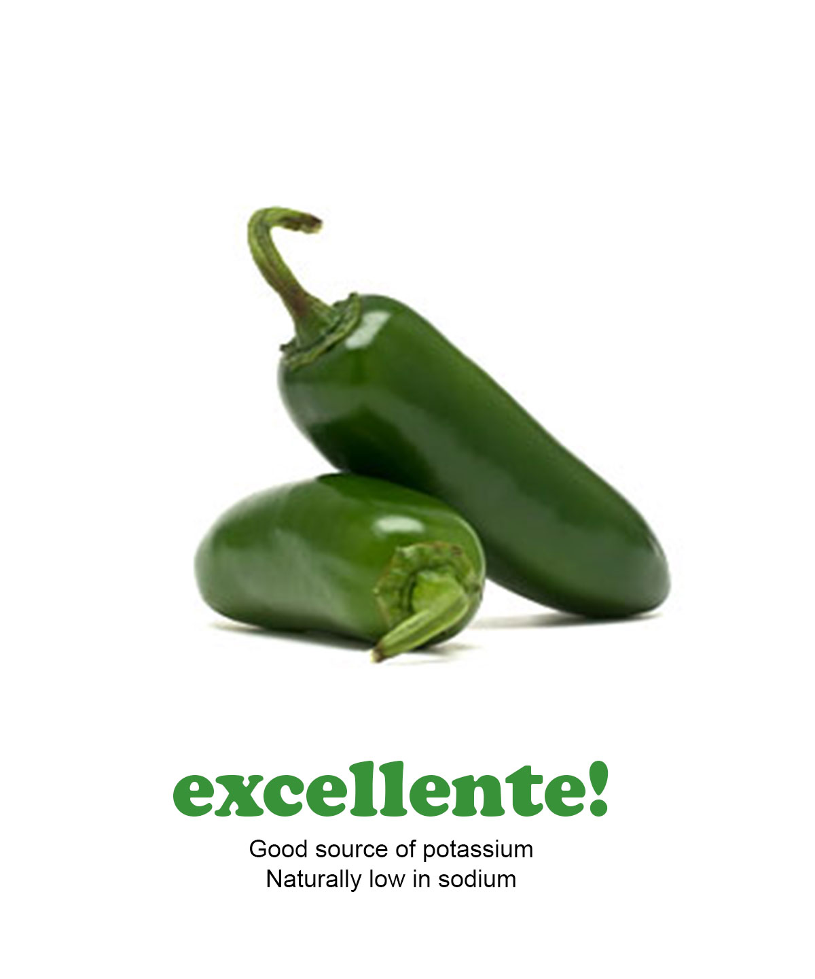

superior to beef superior to jar salsa superior to hot sauce

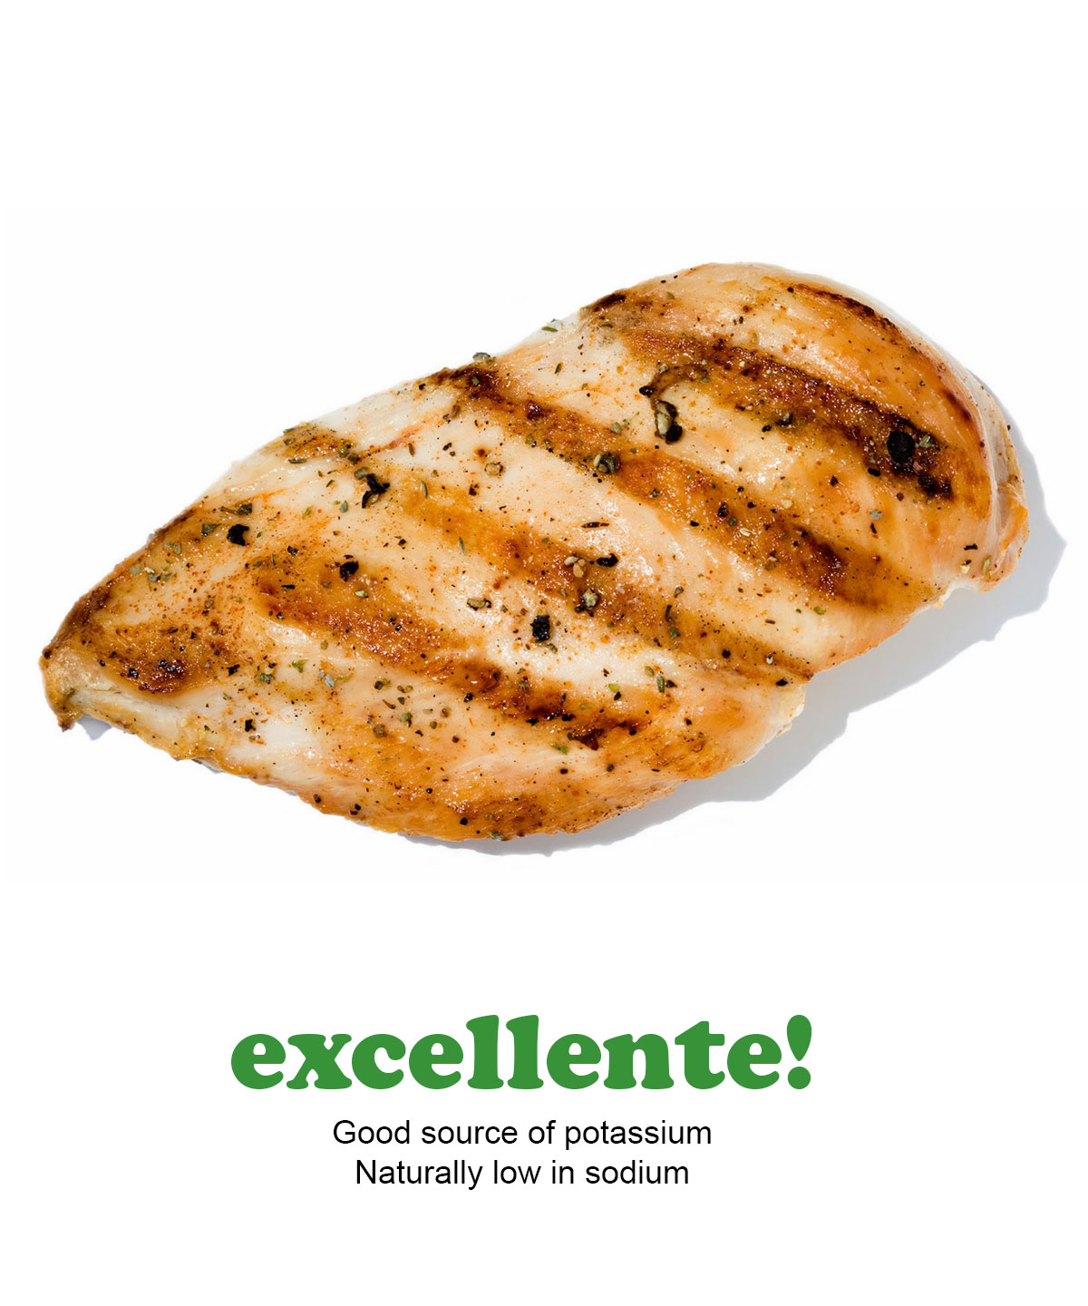 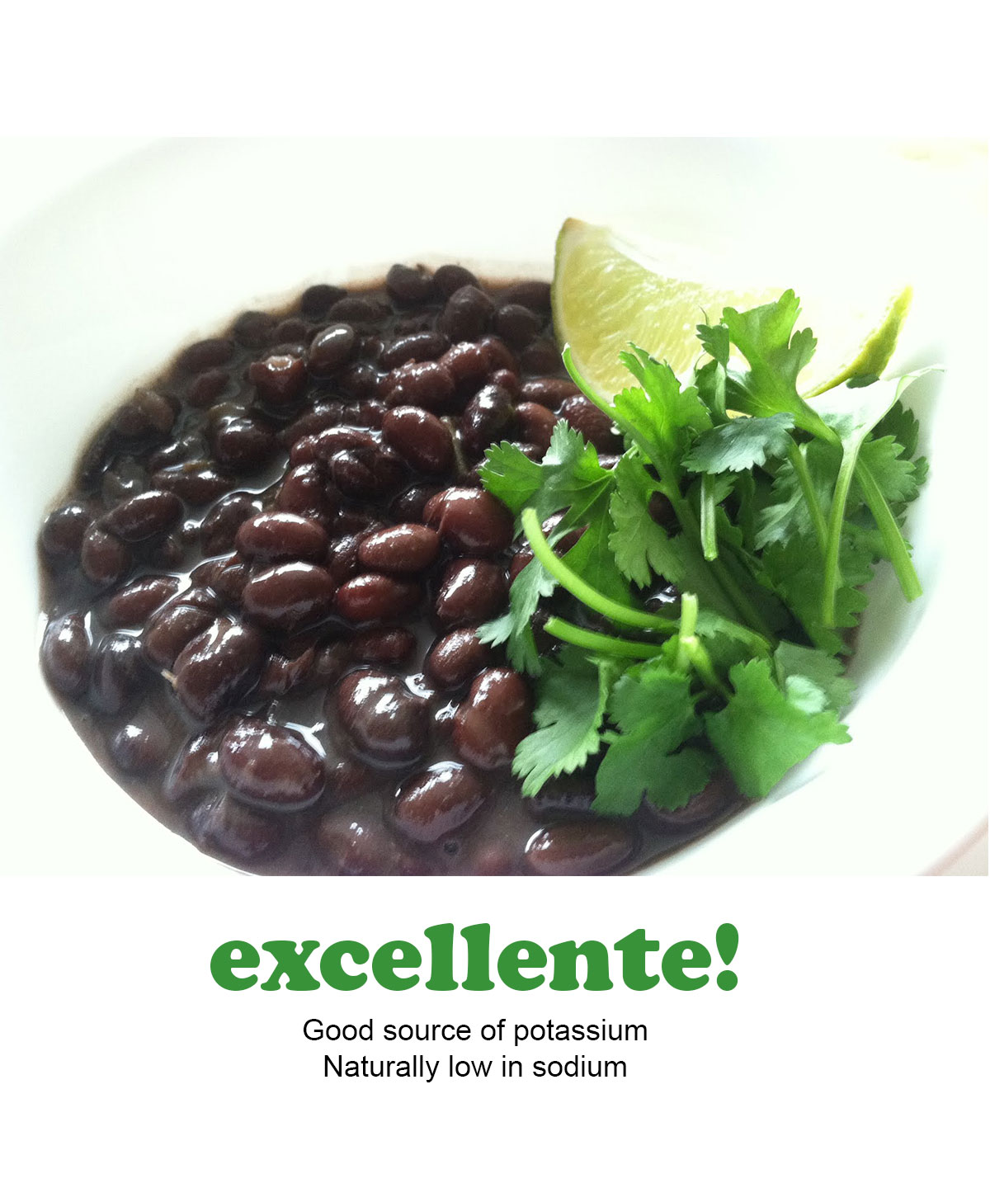 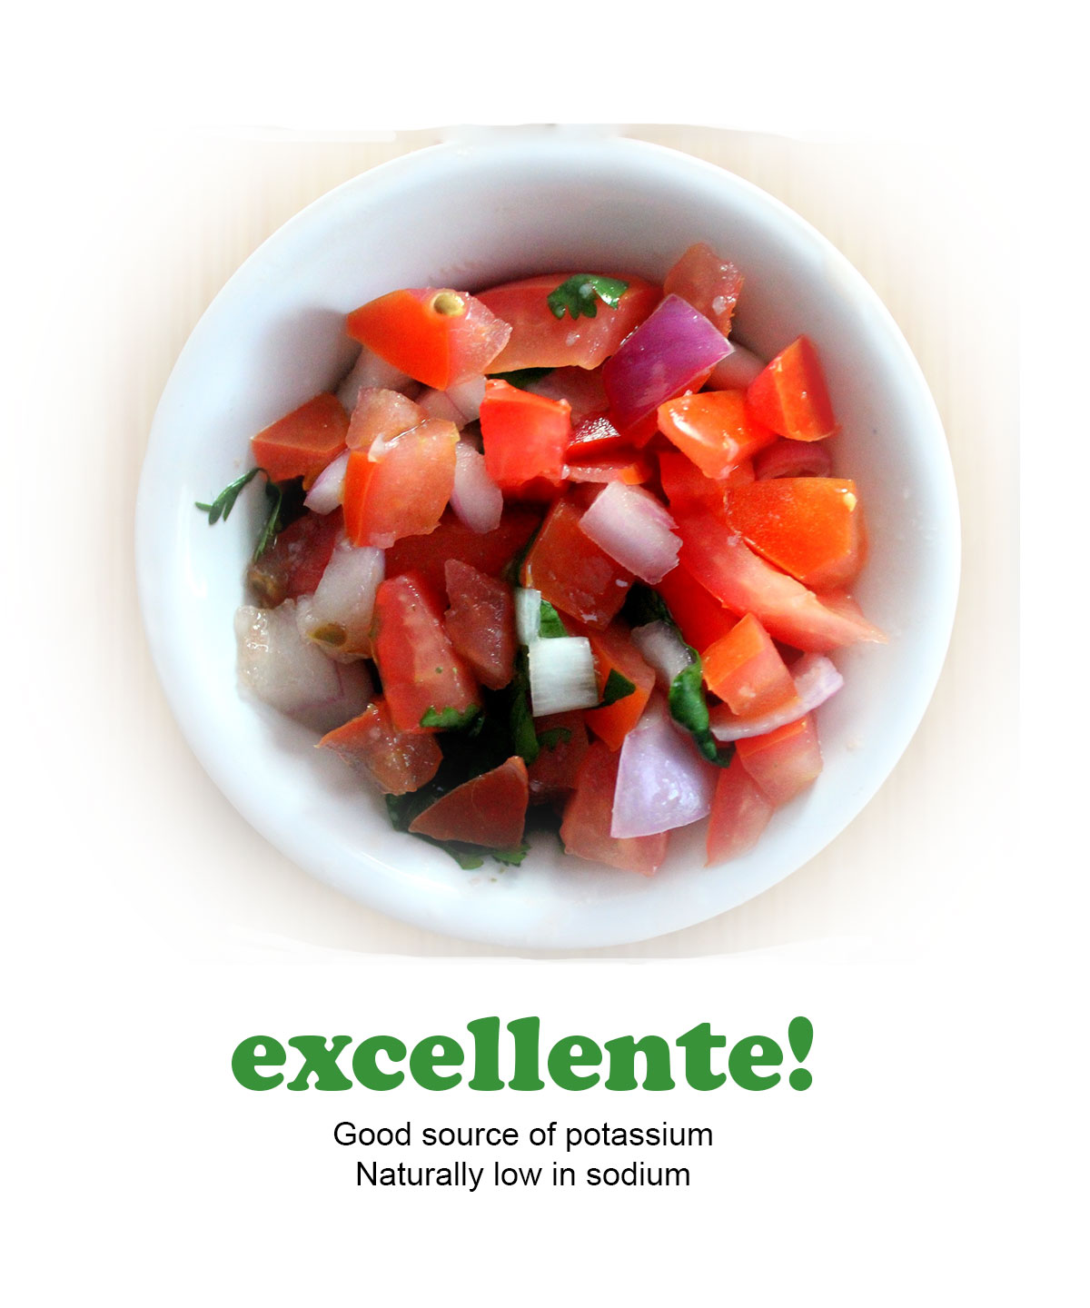

superior to beef superior to beef superior to jar salsa

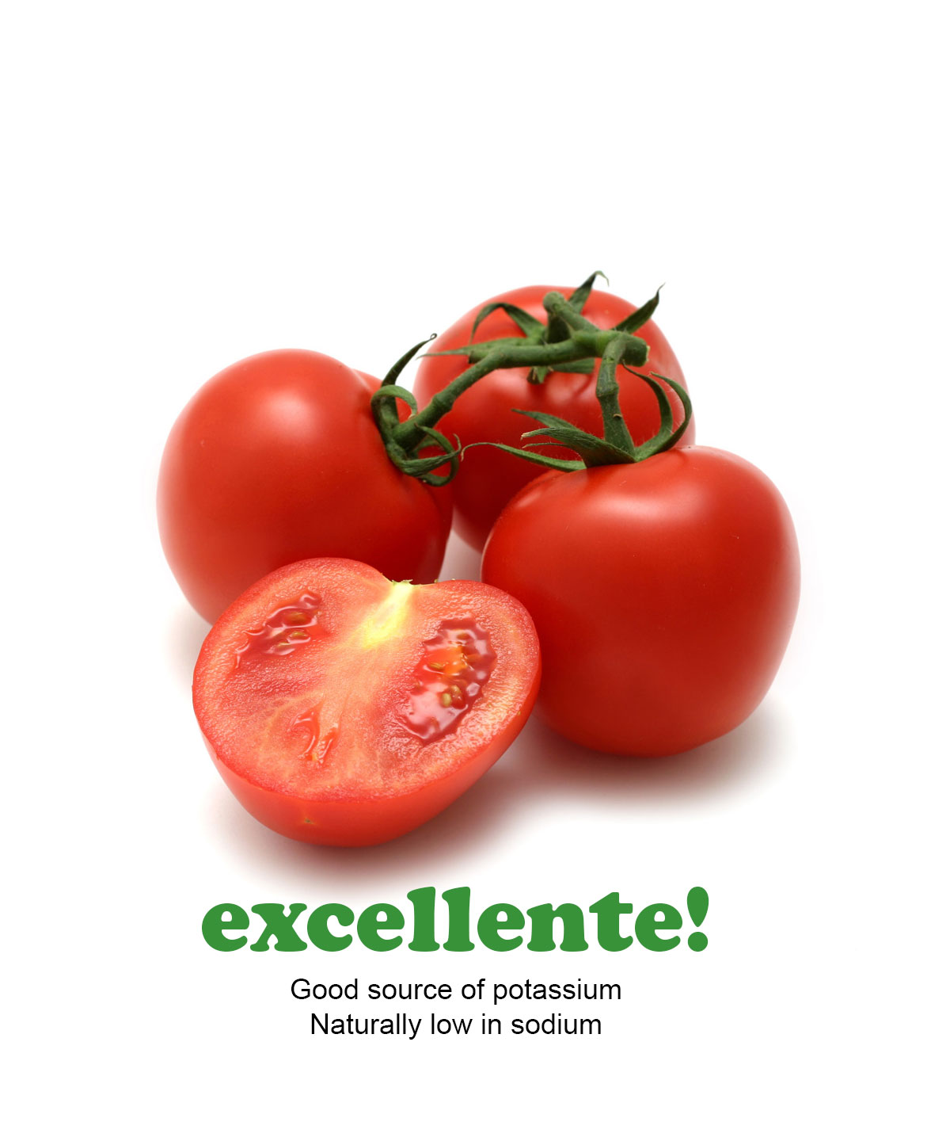 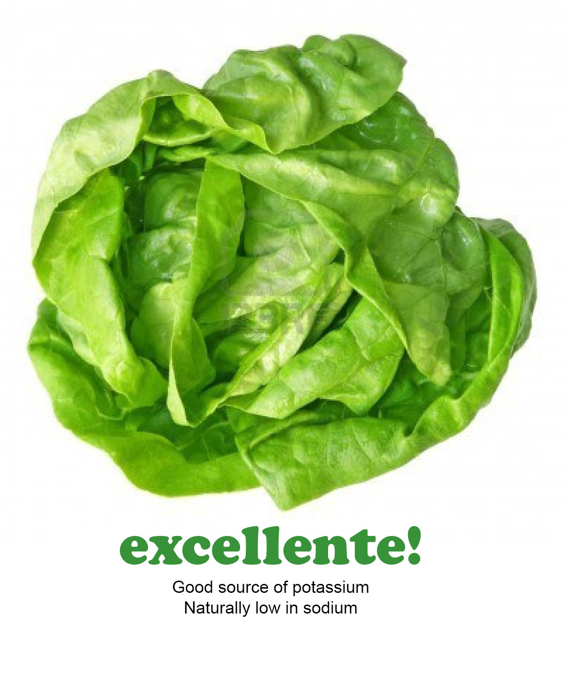superior to jar salsa superior to crunchy taco shell