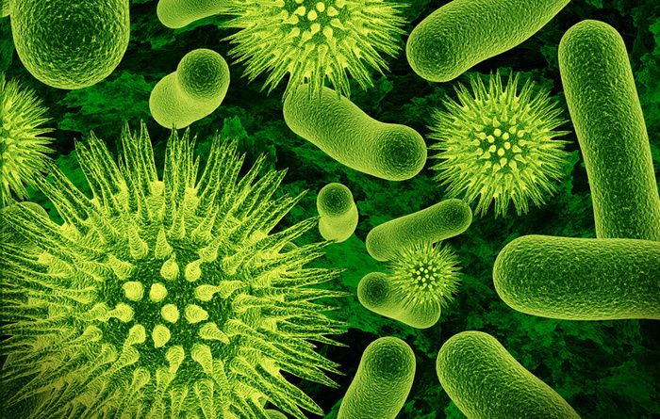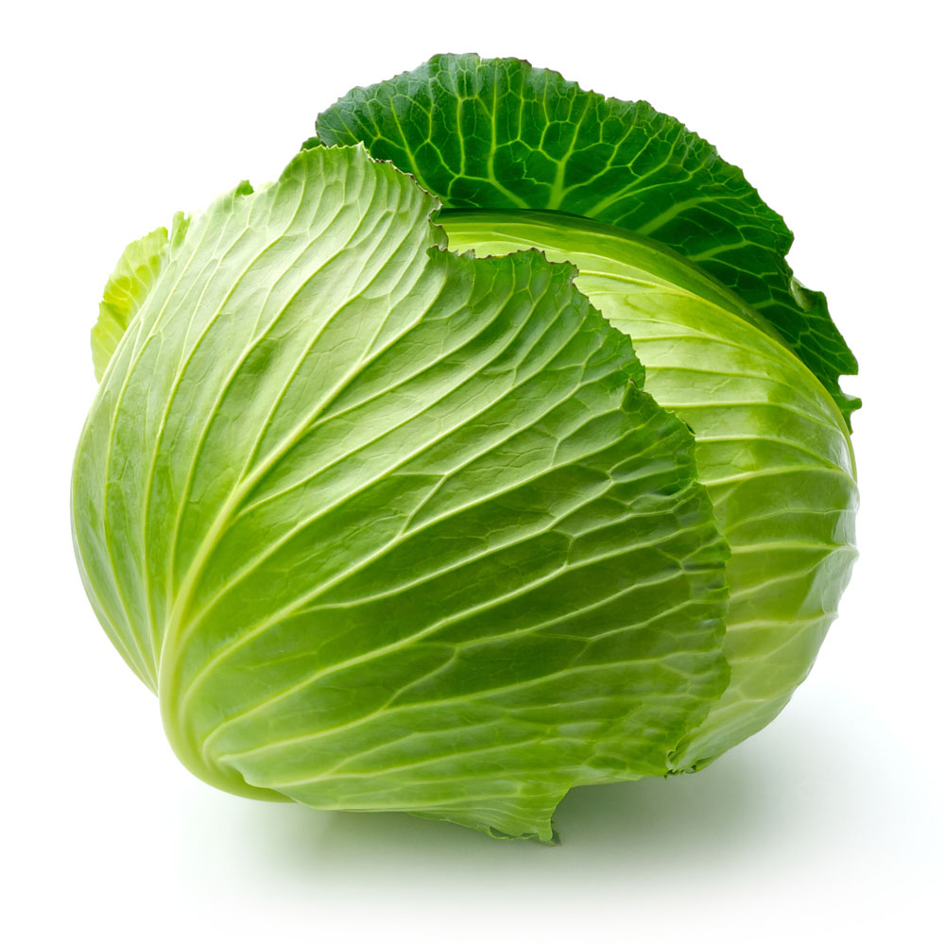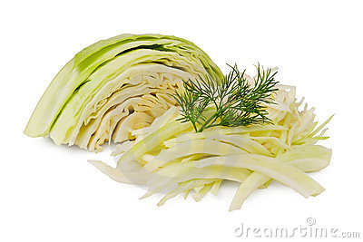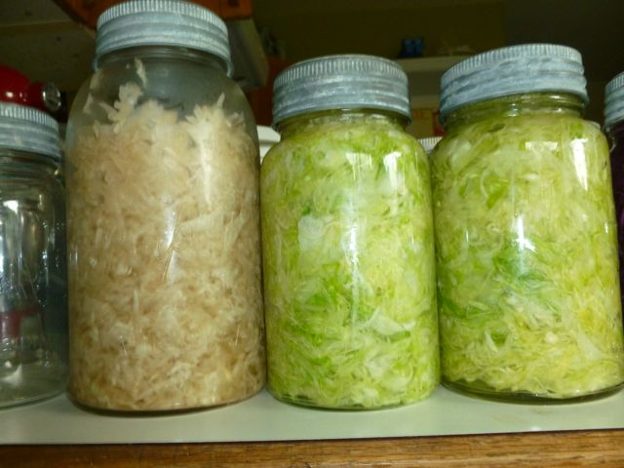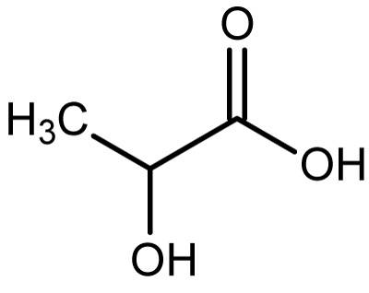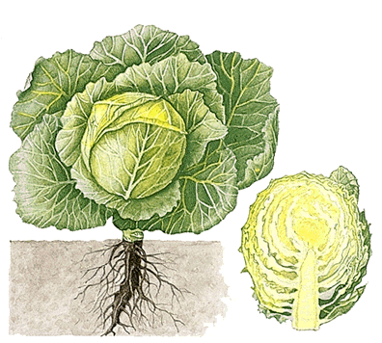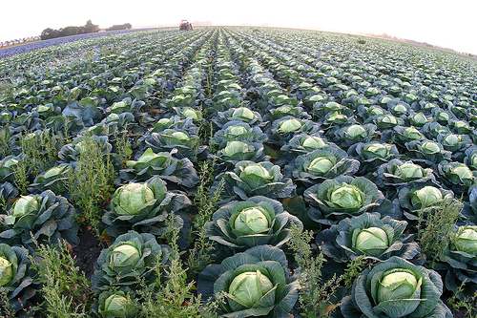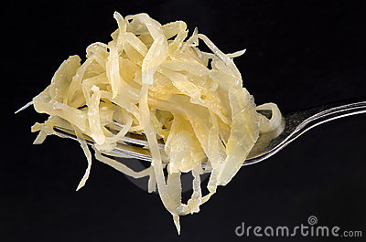

**REFERENCES**

1. 4fa4962747cbd_cabbage.jpg http://www.whatsonchengdu.com/news-3306-the-fresher-the-better-formaldehyde-found-in-fresh-cabbages-in- shandong.html

2. Belitz HD, Werner Grosch, Schieberle Peter. *Food Science*.  City, State: Springer; 2009

3. Blake JS, Munox KD, Volpe S.  *Nutrition from science to you.*San Francisco, California: Pearson Education, Inc.; 2010.

4. Cabbage1.jpg http://bestofmotherearth.com/2009/09/05/sauerkraut.html

5. Cabbage-info0.gif <http://science.howstuffworks.com/life/botany/cabbage-info.htm>

6. Chopped-cabbage-thumb22000374.jpg [http://www.dreamstime.com/stock-image- chopped-cabbage-thumb22000374.jpg](http://www.dreamstime.com/stock-image-%20chopped-cabbage-thumb22000374.jpg)

7. Davis A. How to know if sauerkraut has gone bad when canning. Live Strong. <http://livestrong.com>. July 22, 2011. Accessed February 21, 2013.

8. Denniston KJ, Topping JJ, and Caret RL.  *General, Organic, and Biochemistry.*  New York, New York: McGraw-Hill;

2011.

9. Griffy C. Celebrate national frankfurter and kraut week with recipes from celebrity chefs. <http://examiner.com>. February 7, 2012. Accessed February 9, 2013.

10. Herbst ST. *The New Food Lover’s Companion: comprehensive definitions of over 4000 food, wine, and culinary terms*.  Hauppauge, New York: Barron’s Educational Series, Inc.; 1995.

11. Johanningsmeir, S.  Malolactic activity of lactic acid bacteria during sauerkraut fermentation. *Journal of Food Science; 2004;69(8): M222- M2227.*

12. Karovicova J., Drdak M., Polonsky J., Rajniakova A. Dynamics of production of organic acids during lactic fermentation of vegetable juice. *Journal of Chromatography A; 1994; 665: 55-58.*

13. Katz S. Vegetable fermentation further simplified. Wild Fermentation. <http://www.wildfermentation.com/vegetable-fermentation-further-simplified-2/#comment-6500>  Posted April 27, 2012. Accessed February 5, 2013.

14. Klum, H. <http://www.brainyquote.com/quotes/quotes/h/heidiklum465811.html#cH5qj1jCMEByxpe9.99>

15. Klum, H. <http://nice-cool-pics.com/data/media/22/heidi_klum.jpg>

16. LaBorde L, Wiker N, Zepp M. Sauerkraut. <http://pubs.cas.psu.edu>. 1997. Accessed February 1, 2013.

17. Nutrition Facts label <http://nutritiondata.self.com/facts/vegetables-and-vegetable-products/2614/2>

18. Pandi G. Sauerkraut rises above its humble origins.  *The Gazette (Montreal). 2007: J5.*

19. Pederson CS, Niketic G, Albury MN. Fermentation of the Yugoslavian pickled cabbage.  *Appl. Microbiol.  1962, 10(1):86.*       

20. Margen S. *The Wellness Encyclopedia of Food and Nutrition.*  New York, New York: Health Letter Associates; 1992.   

21. McFeeters RF  Fermentation microoganisms and flavor changes in fermented foods. *Journal of Food Science. 2004; 69(1):35-37.*

22. Mennes ME. Make your own Sauerkraut. <http://learningstore.uwex.edu>. Revised 1994: B2087. Accessed Ferbruary 1, 2013.

23. Mollison, B.  *The permaculture book of Ferment and Human Nutrition*. Tasmania, Australia: Tagari Publications; 2011.   

24. McWilliams, M. *Foods: experimental perspectives.* Saddle River, New Jersey: Pearson Education Inc.; 2012.

25. Oliver L. Reuben Sandwiches. Food TimeLine Library.  <http://foodtimeline.org>. October 6, 2012. Accessed February 12, 2013.

26. Rolek B. Sauerkraut- The Quintessential Eastern European Vegetable. About.com Guide. <http://easteuropean>food.about.com. 2013. Accessed February 10, 2013.

27. sauerkrautonaforkthumb23134491.jpg copyright: Szakaly http://www.dreamstime.com/stock-image-sauerkraut-fork-image23134491

28. Sauerkraut, old and new.jpg http://glenvalleyorganicfarm.blogspot.com/2011_07_01_archive.html.

29. Self Nutrition Data.  <http://nutritiondata.self.com/generate-label/2614/2>.  Updated February 6, 2013.  Accessed February 6, 2013.  
  
30. Well PA, Ward GE. Fermentation Processes. *Industrial & Engineering Chemistry.* 1939; *31 (2): 172-177.*

[cabbage1]

nicole Kielkopf • Keri Palasz

The unique aroma and flavors that combine to become the experience we enjoy as sauerkraut

are credited to production of flavor volatiles that occurs primarily in the early stage of cabbage fermentation. Learn more about this exciting chemical process and its amazing ability

to transform vegetable texture, flavor, and shelf life.

A chemical process

*Scientifically proven to extend cabbage shelf life*

fermentation

From cabbage to kraut in a matter of days

C6H12O6  + ATP → 2 C3H3O3 + 2 ATP (net) + NADH

**Glucose + ATP → 2 Pyruvate + 2 Energy + NADH**

2 C3H3O3 + NADH + 2H+ **→** 2 C3H5O3 + NAD+

**2 Pyruvate + NADH → 2 Lactic Acid + NAD+**

*Fermentation is assisted by the enzyme *lactate dehydrogenase.*

Lactic Acid Molecule

Lactic acid fermentation is one of two types of fermentation that may occur after glycolysis. Glycolysis is the catabolic conversion of starch to a simple sugar, and ultimately to pyruvate. The pyruvate, in anaerobic conditions, is converted to lactic acid in an oxidation-reduction reaction. This process is facilitated by an enzyme, *lactate dehydrogenase,* which removes hydrogen from a molecule of lactate. Lactic acid producing bacteria thrive in anaerobic conditions.23  To keep cabbage fermentation going once it has initiated, the cabbage must be submersed at all times to maintain an anaerobic environment.

In the proper environment, lactic acid fermentation occurs spontaneously at temperatures of 64.4-75.2 degrees F.  Fermentation may continue for 3-6 weeks. In studies, the maximum value of lactic acid in a mixture of fermenting cabbage and carrot juice was measured at hour 64 for the microorganism *L. plantarum (189/86)*, hour 184 for *L. plantarum* (190/86), and hour 184 for *L. delbrukii* (237/86).12  This data may support fermenting cabbage for a minimum of 7 days in order to achieve desired flavors and for food safety.

*Glycolysis:*

*Fermentation*:*

When fermentation begins, the pH of the brine matters.  Belitz measures pH to be approximately 6.2.  This pH will become more acidic as lactic acid forms, lowering the pH to a range of 3.7 - 4.2 within the first 48 hours after fermentation begins.2  Mollison measures the pH to be optimum at 6.5 - 7.5.23  This reduction in pH guards against the development of interfering or harmful microorganisms, which cannot survive in this acidic environment.  The actual amount of lactic acid that will form is, logically enough, dependent on the glucose content of the raw cabbage.  If cabbage does not ferment in a timely manner, sugar may be added to initiate the reaction.  Upon completion, the pH of sauerkraut is around 3.6, which explains the tangy flavor and bite that so many find so pleasing.

A closer look at the chemistry of fermentation shows the conversion of glucose into the products lactic acid, energy (ATP), and carbon dioxide gas.3  Note that in cabbage fermentation yeasts also play a role, so some acetic acid results.  The ratio of lactic to acetic acid is important in the development of flavor.  Typically the ratios are 4:1 and 6:1, respectively.2

Fermentation changes are catabolic reactions with zero net oxidation.8 You need the right microorganisms in the right environment for the right amount of time in order for fermentation to occur.  The amount of salt added is key to establishing the proper environment when fermenting leaves such as cabbage.  There is variation in the exact amount of salt necessary for leaf ferments.  Pandi claims that sauerkraut salt levels are maintained around 3% by weight.18 Belitz directs salt levels should be 1.8-2.5%.2  Mollison advises use of 20-30% salt, by weight, to cabbage weight.23 And then there is Katz, who claims that there is no magic proportion of salt required to ferment cabbage, it is a personal preference.13   Note that higher salt concentrations will slow fermentation, while those with low salt concentrations will ferment more quickly and also be more susceptible to developing surface mold.  Controlled pH in sauerkraut enables production of lactic acid (the source of that tart flavor), improves texture, and simultaneously preserves the food.

**Fermentation: a series of chemical changes**

[sauerkraut, old and new28]

* Flavor changes from sweet to tart
* Texture changes: the result is crisp with a denser bite than raw cabbage
* A gel forms as a large amount of B-lactoglobulin is bound to casein molecules.24
* Shelf-life increases from days to months
* Sugar is converted to lactic acid
* Volume of cabbage decreases as the fermentation proceeds

**Which Microorganisms participate in fermentation?**  
Three classes of microorganisms - yeast, mold, and bacteria - participate in the process of fermentation.  Yeasts produce alcohol and glycerol.  Molds produce citric acid, gallic acid, and gluconic acid.  Bacteria produce butyl alcohol, acetone, sorbose, acetic acid, and lactic acid.30  In the fermentation of cabbage, bacteria is the active microorganism.    
  
**Two Types of Fermentation**  
In addition to three classes of microorganisms, there are also two main categories of fermentation:  surface and submerged. The anaerobic or aerobic tendencies of different microorganisms generally dictate which form of fermentation they participate in.  Surface fermentation occurs when occurs when the microorganisms develop on a pellicle on the medium surface.  Submerged fermentation occurs when the microorganisms develop while submerged in a solution, and is anaerobic.

Yeast and bacteria typically perform submerged fermentation, while mold and aerobic bacteria perform surface fermentation.30 The fermentation of sauerkraut involves submerged, anaerobic fermentation which produces lactic acid.

**Effects of Fermentation on Cabbage**

Sauerkraut can be stored a few different ways after fermentation has occurred.  Two short-term alternatives would

be to refrigerate or leave in a crockpot.  The crockpot can be used to store kraut if placed in a cool area such as a garage.  The key to keeping freshness is to avoid exposure to air because this will cause the product to spoil faster.

It is important to check for spoilage on the top [chopped cabbage6]

and remove it each time the pot is opened.  When

closing the pot one needs to cover as quickly

as possible, and weight the lid to avoid any

additional air from coming in contact

with the product.  Kraut can also be held in

a refrigerator for several months if stored in

freezer bags or tightly closed jars.  This is

the easier alternative for short-term

storage if the room is available.22    
  
Several long-term storage options are available, which

include freezing and canning.  Freezing is the easier solution

where kraut is put into vapor-proof freezer containers, freezer bags,

or glass jars in which 1 ½ inches is left empty on top.  Canning is another

option which is more difficult, but effective if done properly.  Fermented sauerkraut is heated to 185-200 degrees F. Be careful because the sauerkraut shouldn’t boil.  Kraut will then be placed into hot jars making sure to leave ½ inch space on top. Make sure juice is covering the kraut entirely.  Clean, pre-treated lids are placed on jars and placed in a 212 degrees F boiling water canner for 15-20 minutes per four quarts.  If unopened sauerkraut can last up to eighteen months.7  These are great ways to enjoy homemade sauerkraut for long periods of time since

the fermentation process is lengthy.22    
  
There are signs which show that sauerkraut has gone bad and should be discarded immediately.  One easy to

observe sign is the presence of mold on the surface.  Other indicators include a slimy texture when touching and

a rancid smell.  The touch should be moist and the smell tangy and comparable to vinegar in safe kraut.7

**Storing Sauerkraut**

The unique aroma and flavors that combine to become the experience we enjoy as sauerkraut are credited to production of flavor volatiles which occurs primarily in the early stage of cabbage fermentation.  A balance between lactic and acetic acids is established in these early stages.  Without these volatiles and balanced acids, the experience of eating sauerkraut simply would not be.  Early cabbage fermentation is predominated by a type of heterofermentative lactic acid bacteria (LAB), *Leuconostoc mesenteroides* or *Lactobaciltus brevis*.  Some cultures of L. mesenteroides are able to decarboxylate L-malic acid to L-lactic acid and CO2, affecting pH in the process.  This reaction is desirable in early sauerkraut production. Early conversion of malic acid to lactic acid can influence the pH rate of change.  Controlling the rate at which the ingredients transform from basic to acidic influences growth of various bacterial species, which ultimately affect flavor of the finished product.11

**What is happening to the cabbage?**  
Cabbage tissue, exposed in shredding, interacts with salt. Water is pulled out of the cabbage cells through osmosis. The cabbage cells, deplete of their water, collapse, leaving the once crisp cabbage deflated.  The deflated cabbage is crunchier than it was in its original state.

This textural change is due to the salt hardening pectins in the cabbage.  The salty brine further protects the cabbage by discouraging growth of bacteria

other than lactobacilli.  This specific inhibition of other bacteria enable the cabbage to ferment, not decompose.13

Water released from the cabbage mixes with salt, creating a solution referred to as *brine*. Resident cabbage bacteria are activated when the brine reaches different pH levels.  Activated bacteria are able to access nutrients such as glucose in the exposed cabbage tissue.  They break down glucose in the cabbage, producing lactic acid.  As the level of lactic acid increases, the pH of the mixture becomes more acidic, so it decreases.

Sauerkraut.  It turns noses.  If you enjoy this tangy, textural dish, the mere name conjures up salivating memories.  Tender roasted loin of pork in your Grandmother’s kitchen, that first snapping bite into a hot dog on an early spring day in the park, or the unctuous comfort of a Reuben sandwich may come to mind.  If you do not consider sauerkraut a treat, however, its pungent aroma will still turn your nose - although in the other direction.          
  
Translated from German, *sauerkraut* literally describes the dish, “sour cabbage.”   This aromatic combination of shredded cabbage, salt, and spices, which gains much of its flavor through fermentation, is not of German origin, but Chinese.  Laborers building the Great Wall of China ate a similar dish fermented with rice wine.  That recipe eventually made its way to Europe where it found favor and solid standing in kitchens in Germany, Switzerland, Austria, Slovakia, the Czech Republic, Hungary, and the Alsace region of France.10  The recipe, and possibly the food itself, was carried into America where it continues to turn noses.      
  
Regardless of whether you follow a Chinese, German, or Alsatian recipe for sauerkraut, there is more to the preparation than combining appropriate quantities of shredded cabbage with salt and spices.  Time, temperature, and tiny microorganisms play roles in the preparation of this recipe.  With careful monitoring, this trio facilitates the process of fermentation provided that the cabbage is completely submerged in liquid.13  Fermentation transforms the raw starting ingredients into a result with a distinctly different flavor, texture, appearance, and shelf life.  Shelf life of fermented cabbage is increased specifically due to the acidic pH of the product, which inhibits growth of bad bacteria.

Lactic acid is a short carbon chain carboxylic acid produced when glucose is oxidized.  As an acid, it will dissociate in water, releasing its protons. However, carboxylic acids are weak acids, with less than 5% of the acid in solution donating its proton to become ionized.8   The three-carbon backbone of this molecule has a low molecular mass, sharp sour taste, and a unique aroma.  Lactic acid is often used as food preservative to lower the pH to a level in which bad bacteria do not grow. This is the case with sauerkraut.  
  
Lactic acid fermentation begins when a monosaccharide, glucose, enters the glycolysis pathway.  Glycolysis is an anaerobic process that is completed in a series of 10 steps.  Three products result from glycolysis:  ATP (chemical energy), NADH (chemical energy), and pyruvate.    In anaerobic conditions Nicotinamide Adenine Dinucleotide is in its reduced form (NADH).  It is important that this form of NAD is present, as it then provides electrons for use in fermentation reactions.  The pyruvate, in anaerobic fermentation conditions, is then used to accept electrons.8 This reduction reaction is catalyzed by the enzyme lactate dehydrogenase in anaerobic conditions.     
  
 Lactate fermentation begins after glycolysis  
 **Pyruvate +NADH ------> lactic acid + NAD+**  
   
Sequential fermentation of sauerkraut is initiated by heterofermentative lactic acid bacteria, dominently *Lueconostoc mesenteroides and Lactobacillus brevis*.  The process is ultimately completed by homofermentative bacteria like *Lactobacillus plantarum and Pediococcus cerevisiae*.  Typical sauerkraut flavor is a result of the fermentation process.

The mere acidification of cabbage does not result in the odor or flavor identified with sauerkraut.  It is important to note that the exact generation of sauerkraut flavor during the process of fermentation is not yet fully understood.21   
  
In homolactic fermentation, one molecule of glucose is converted to two molecules of lactic acid:

**C6H12O6 → 2 CH3CHOHCOOH**

In heterolactic fermentation, one molecule of glucose is converted to one molecule of lactic acid, one molecule of ethanol, and one molecule of carbon dioxide:

**C6H12O6 → CH3CHOHCOOH + C2H5OH + CO2**

As mentioned, this simple equation occurs in sequenced steps when the appropriate microorganisms are in an appropriate environment.

**From humble head of cabbage to tart treat**

[Cabbage14]

[cabbage-info05]

**Meet Reuben**

One well-known selection for the enjoyment of sauerkraut is the Reuben. This warm sandwich is composed on rye bread with Swiss cheese, thousand island dressing, corned beef and of course, sauerkraut.

There are competing stories regarding this sandwich’s creator.  Some believe it was Arnold Reuben from New York. Others believe it was invented by Reuben Kulakofsky from Omaha, Nebraska.25 Regardless of who you credit, it’s one tasty and popular sandwich.

The Swiss heat sauerkraut with black mustard seed, Juniper berries, onions, and Champagne, then serve it with a topping of crunchy roasted peanuts.23  Great recipes using kraut are continuously being created by chefs and home cooks alike.

**Malolactic reaction**

**Lactic Acid = Sour Taste**

[sauerkraut on a fork 27]

Sauerkraut is known around the world by many and is becoming

even more popular everyday.  This fermented cabbage dish is

recognized as *sauerkraut* in Western Europe and as *kim chee* in

Korea.23   Traveling originally from China to Eastern Europe

1,000 years later, sauerkraut was brought to the United States

by European immigrants.  These immigrants, also known

by many as the Pennsylvania Dutch, brought the tradition

of eating pork and sauerkraut on New Year’s Day to bring

good luck throughout the coming year.26  Sauerkraut has

traveled from Pennsylvania throughout the United States

through the years and continues to grow in popularity.  
  
“National Frankfurter & Kraut Week” was created to

celebrate sauerkraut on hot dogs and is held the second week

of February every year.  Also bringing attention to cooking

with sauerkraut are popular chefs that use television to share

recipes such as Alton Brown in *Good Eats*, Robert Irvine in *Diner*

*Impossible*, and the well-known Michael Symon from *Iron Chef*.  With

this national attention sauerkraut continues to reach more audiences

than ever before.9  
  
In addition, kraut is also being popularized as a ‘Super Star Food’ in the United States.  Supermodels Heidi Klum and Anna Azarova shared their love for this, their favorite food. Klum also stated that it has helped contribute to her success keeping thin as a supermodel.  Some of the benefits which helped sauerkraut earn such a high ranking include high levels of vitamins and minerals, status as an immune booster, ability to balance bacteria in the gastrointestinal tract, possible “flu fighting” qualities, and antioxidants thought to fight cancer.26

**“I'd say I'm a good cook. I have a lot of German recipes that I can make - schnitzel, meatballs and things with cabbage.**

**I love cabbage.”– Heidi Klum, Supermodel** [Klum, H. 14]

**Why preserve cabbage?**  
Cabbage is a natural source of vitamin C, and while in season,

is often inexpensive.  Without some form of preservation,

green cabbage heads will keep for approximately two weeks

if held in a cold, refrigerated environment. Cut, raw cabbage

will hold for a day or two if tightly wrapped with plastic

wrap and stored in the refrigerator.20  Fermentation can

improve cabbage nutrition not only by conserving vitamin

C resident in the cabbage at the start of the process, but also

by the synthesis of vitamins B and K.23

[Nutrition Facts17]

**Food Safety Concerns**

The process of fermenting sauerkraut involves important attention to food safety consider-

ations.  Selecting cabbage is the first step to fermenting kraut and heads should be picked from mid to late season and crops should be firm, sweet, with mature heads.  Outer leaves need to be discarded, cores removed and worm and diseased parts thrown away.

In the process of fermenting, sauerkraut needs to be covered with several layers of cheesecloth or a clean towel. This keeps airborne mold spores out of the process and helps keep the cabbage submerged.

Kraut will need to be kept at temperatures between 60-75 degrees F when fermenting.  If held any lower, it may not ferment. At any higher temperature, it will spoil. If jars are used as weights in the process, the kraut needs to be checked 2-3 times a week to remove scum that may be present.16 This scum, also called a *bloom*, is a type of mold that only appears on the surface during the fermentation process as a result of contact with air.

The sauerkraut itself will not be harmed by this bloom of mold, as it is protected by the anaerobic nature of the brine.13  If kraut appears to have a slimy texture, bad smell or a growth of mold or yeast it should not be consumed, but discarded.16  
  
There are a few signs in particular to watch out for when preparing or eating sauerkraut.  Some red flags include softness, pink color, rotted kraut, and darkness.  These can be associated with a number of problems during fermentation such as improper amount of salt, wrong temperatures, yeast growth that shouldn’t be there, kraut not being covered properly, unwashed cabbage, or improper storage and packaging.22

[Klum, H.15 ]

**Sauerkraut as Superfood**

**Cabbage Fermentation 101**

**Starting Materials**

**Raw cabbage**, which contains resident LAB

**Resident Cabbage Bacteria (LAB)**:

Heterofermenters - *L. mesenteroides*, *L. brevis*

Homofermenters -*Pediococcus cerevisiae*

**Malic Acid** - a natural component of cabbage

**Salt**

**Additions**

Flavor can be modified with a variety of ingredients. Caraway seeds or apples are often popular additions.

**Environmental Conditions**

Resident Microflora on the cabbage (LAB). It has been reported that the heterofermenter LABs are able to react more when cabbage is shredded.19   Logic would explain this increased effect through the increase in surface area of shredded cabbage over whole cabbage heads.

Salt in desired concentration for texture, flavor, and preservation

Vessel, preferably ceramic or glass.  Plastic can leach chemicals into the kraut.  Metal will corrode due to exposure to salt and acid during fermentation. Harsch crocks are designed specifically created for the fermentation of vegetables.  By design, they create an air-free space around the ferment to inhibit aerobic surface mold growth.13

Temperature maintained within the range of 60-80 degrees Fahrenheit

Time range from 2-21 days.

Many recipes advice to “ferment until ripe.”13 The lactic acid that accounts for the sour, tangy flavor of sauerkraut develops over time, so the longer the ferment, the tangier the result.

**Preparation:** Shred the cabbage.  Pack a layer of cabbage into a barrel, stomping down with bare feet. Sprinkle with salt.  Continue layering until barrel is packed.  Place lid on top of barrel and weight down with stones so that is in contact with the cabbage. Allow to sit for at least three weeks, or until cabbage has turned from green to white.

**Traditional Sauerkraut Recipe**18

* Cabbage, green
* Coarse salt
* Large barrel with lid that fits inside barrel
* Several heavy stones